1.**Get All Customers In Hall Booking App**

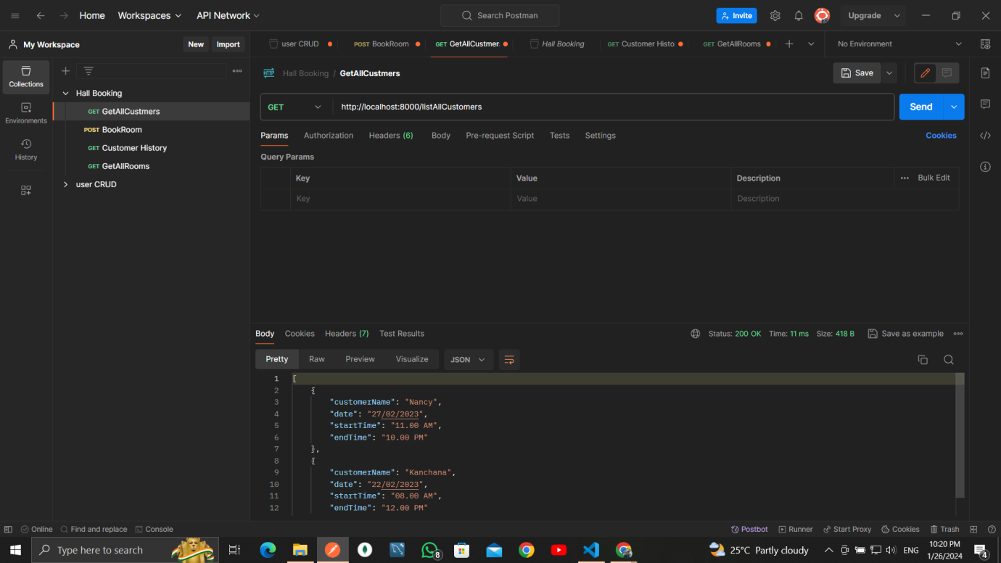

**2.Book the Hall in Hall Booking App**

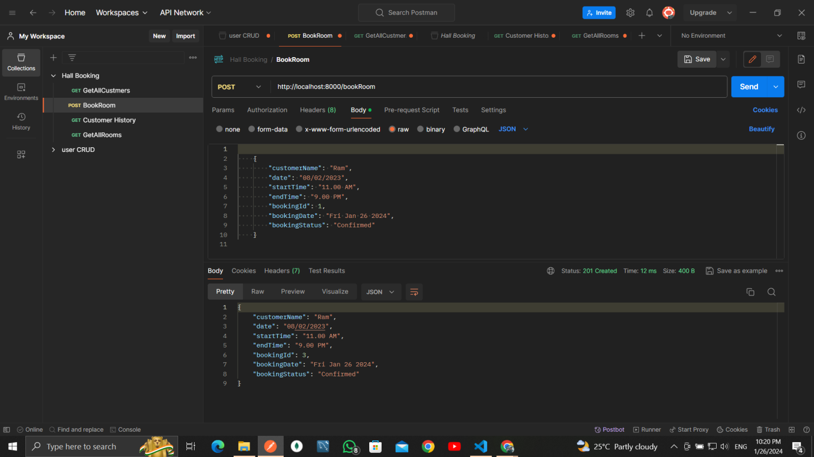

**3.Get All Rooms In Hall Booking App**

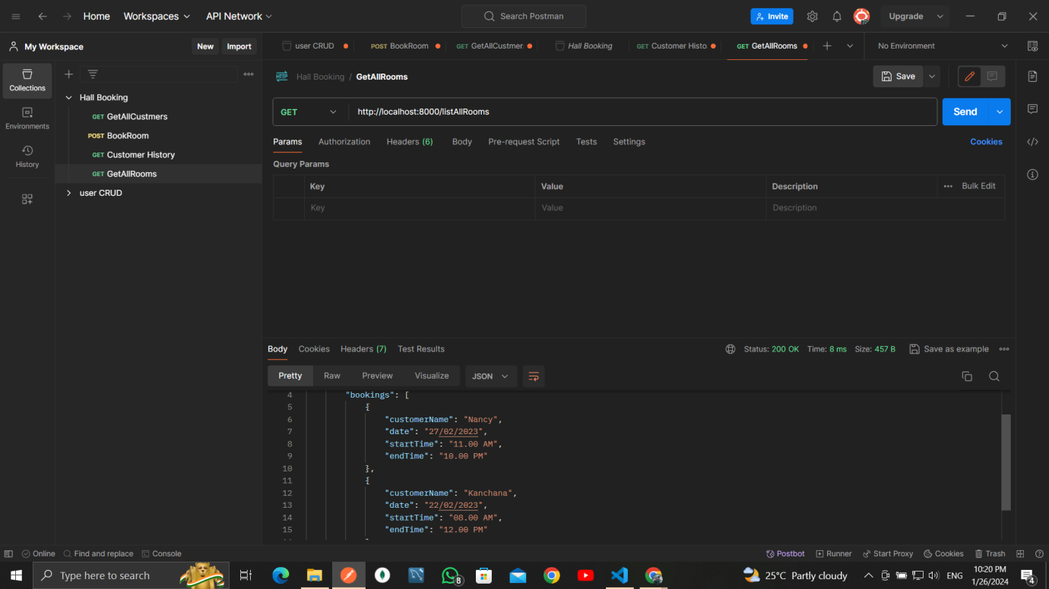

**4.Get Customer Details in Hall Booking App By Using Customer Name**

